**Appendix A. Broadband Regulatory Framework**

The United States primarily deploys a private model of broadband service provision.[1] Broadband service is generally provided by telephone and cable companies, both of whom upgraded their traditional voice and video networks, respectively, to offer data services. These broadband service providers (henceforth BSPs) invest significant capital resources into constructing, operating, and maintaining a large network of cables and facilities that house data centers, servers, and routers. Since these key components of broadband infrastructure must be integrated into the existing built environment, the providers need access to poles, ducts, and conduits, as well as the rights-of-way (both public and private) within which their broadband infrastructure can be housed. Once the physical infrastructure is in place, BSPs also must adhere to policies regulating the provision of services. This process of accessing and obtaining permission to use existing facilities, construct new infrastructure, and provide internet services is governed by a multitude of federal, state and local policies.

The following Appendix summarizes the major features of federalist broadband regulation.

***Wireline Broadband Infrastructure: Who regulates what?***

There are three primary modes of wireline broadband provision today: Digital Subscriber Line (DSL), Cable, and Fiber Optic Cable. All these modes require the construction, operation, and maintenance of a physical cable network. DSL uses phone lines to provide broadband service, while cable modems transmit digital data over cable television lines. Fiber optic cables are a newer and faster technology, and they contain strands of glass fibers inside an insulated casing. The deployment of fiber optic cable is still in its infancy in the US, making DSL and cable broadband the dominant modes of internet service provision. [2] It’s also important to note that cable broadband companies can update their infrastructure capabilities without retrenching their networks, while DSL providers would need to do so.

The cable network for these three modes can be constructed in three primary ways: *underground installation*, where cables are placed in conduits that are then buried underground; *buried installation*, where cables (with or without protective ducts) are directly buried in the ground; and *aerial installation*, where cables are attached to existing utility poles. Trenches for underground or buried cable are most commonly dug alongside existing infrastructure networks, such as highways and roadways. Cables may also require supporting infrastructure such as pedestals, manholes, and controlled-environment vaults. The installation of the cable network and its associated components thus requires permission (most often from city or local governments) to access and modify the existing built environment.

The top half of Figure A1 depicts the typical pathway for broadband service provision, while the bottom half points to key regulatory policies at the federal, state and local levels that govern important points along the pathway. The top half of the figure illustrates the key components of physical infrastructure for wireline broadband provision, from the backbone to the end user. The Internet relies on a backbone to carry data over long distances. The backbone consists of several ultra-high bandwidth connections that link together at key network nodes all over the world. Next, an Internet Exchange Point (IXP) facilitates the costless/low-cost exchange of internet traffic between different provider networks through mutual peering agreements. Finally, at a point of presence (PoP), a long-distance carrier’s cables typically end and connect into a local regional or city network. From the point of presence, internet traffic is routed to the end user.

**Figure A1: Fixed Broadband Infrastructure System in the United States**

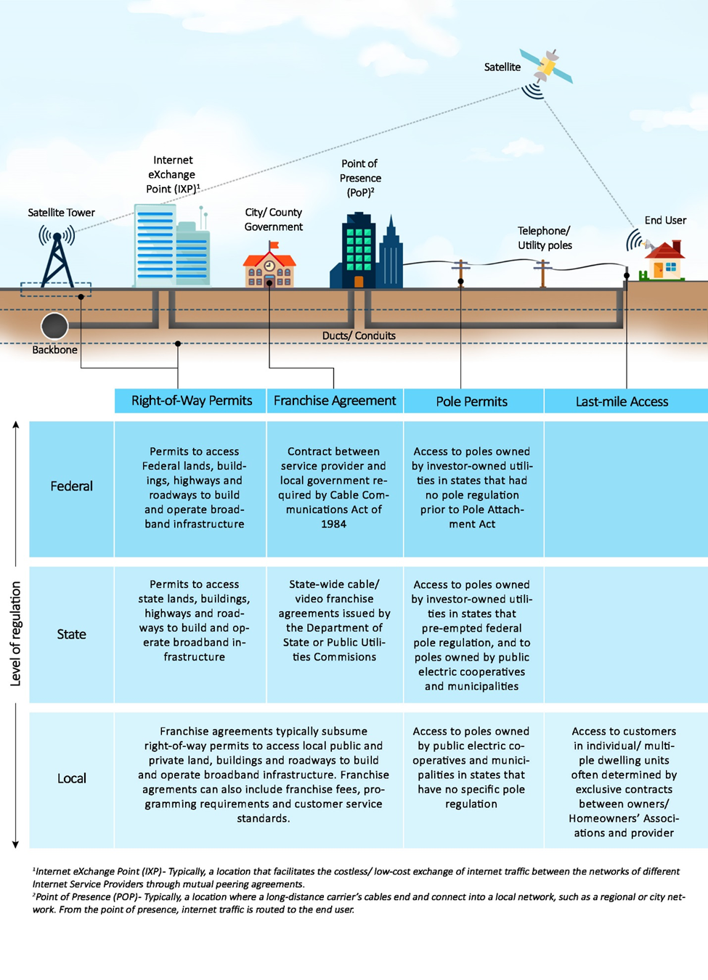

*Source: Brookings Institution*

***Rights-of-way***

Rights-of-way permits determine access to the public transportation and utility corridors as well as the private land required to build a broadband network. These permits are typically part of franchise agreements with local governments. However, governments at all levels may exhibit regulatory authority, including federal, state, local, and even tribal governments.[3] For instance, the United States Department of Transportation (USDOT) governs access to federally-assisted highways. Below the federal level, rights-of-way policy is often inconsistent between different states and cities. To add to the complexity, rights-of-way are also used by other utilities, including electricity, water, and gas utilities.

In 2012, President Barack Obama signed an Executive Order to facilitate broadband deployment on federal lands, buildings, rights of way, federally-assisted highways, and tribal lands.[4] The order created an interagency working group composed of a number of federal agencies, including USDOT, with a goal to reduce barriers to the expansion of broadband services in underserved communities. The Order required USDOT’s Federal Highway Administration to review “dig once” requirements in existing programs, in order to coordinate the placement of underground fiber optic cable along highway and roadway rights-of-way. This includes provisions such as imposing a moratorium on street excavation to preserve new roadways, installation of empty conduit in the right-of-way during new construction, and the use of trenchless technologies, such as horizontal directional drilling or micro-trenching.[5]

***Franchise Agreements***

The Cable Communications Act of 1984 requires city, county, or state governments and cable television providers who offer internet service to sign a contract known as a franchise agreement. Before any service provider can install any infrastructure, there is typically a bid process wherein governments request bids from providers who wish to provide service to their citizens. This is followed by a franchise negotiation and the signing of a contract agreement between the government and the provider, which is typically renewed in 10-year intervals. Note that local franchise requirements legally apply only to television cable companies, but today, internet, television and voice provision (telephone) are often bundled into a single package by a provider. This can bring the internet service providers under the purview of these agreements.

A franchise agreement is a contract that typically covers rights to access public and private rights-of-way, to construct and operate infrastructure, and to provide customer service. It can also include service standards, franchise fees of up to five percent of the provider’s gross revenue, and provision of public, educational, and government programming. Critically, those standards can mandate ubiquitous service to all neighborhoods within a service territory. However, these agreements cannot determine the prices of service provision.[6]

The ease of negotiating with governments and the concessions they can provide often play a key role in broadband deployment. According to the GAO, providers can be sensitive to how receptive state and local government officials are to new market entrants.[7] They specifically consider the degree to which state and local government officials make efforts to reduce the considerable administrative requirements, which can pose a significant barrier to entry. More recently, when telecommunications companies started providing video services, a large number of states changed the law to allow for statewide franchising.[8]

***Poles, Ducts, and Conduit Access***

There are roughly 134 million poles owned by various entities in the US, including private investors and public agencies such as electric utilities and municipalities.[9] Access to poles, ducts, and conduits is often crucial to attach cables/wires to existing poles or future small cell facilities. Based on pole ownership, BSPs need to apply for permission to access the poles in accordance with the federal Pole Attachment Act, as amended by the Telecommunications Act of 1996.[10] These rules apply differently to investor-owned utilities versus public electric cooperatives and municipalities. When poles are owned by investor-owned utilities, then, there can be one of two situations:

* States whose investor-owned utilities are regulated by the FCC for pole attachment purposes; or
* States whose investor-owned utilities are regulated by the states themselves as the states have preempted federal regulation of pole attachments.

The 1996 Act exempts public electric cooperatives and municipalities from any federal pole regulation. It is therefore left to the individual states to decide how to regulate them. Some states have state-level regulation in place, while some don’t, in which case the BSPs have to negotiate with individual cooperatives and municipalities in order to secure access to poles. This can be an expensive and time-consuming process.

In recognition of the barrier posed to timely and cost-efficient broadband provision by the lack of access to poles on reasonable rates and conditions, the FCC has tried to simplify and hasten the process. In 2010, FCC’s National Broadband Plan included a recommendation to establish rental rates for pole attachments that are as low and uniform as possible to promote broadband deployment. In 2011, the FCC reformed its pole attachment rules and issued the Pole Attachments Order to streamline access to utility poles across America.[11] State legislatures, too, have been under pressure to create consistent and favorable rules for pole attachments.

Pole access and related policies will only continue to gain interest from BSPs and governments as emerging technologies like 5G require new pole infrastructure in the coming years.

***Last-mile Access***

Individual buildings and their homeowner associations (HOAs), especially apartments classified as multiple tenant environments, often have exclusive contracts with incumbent cable operators to provide broadband to their residents. This can pose a problem to new BSPs trying to use the existing infrastructure within the buildings to provide service, as well as to the installation of new technologies such as fiber. In response to this issue, the FCC released a Notice of Inquiry in June 2017 seeking comment on the need to reduce barriers faced by broadband providers seeking to serve multiple tenant environments.[12]

***Broadband Service Provider Limitations***

While the vast majority of BSPs are privately-owned, there are publicly-owned broadband service providers in many communities. In many states, laws can prevent local governments from building public broadband networks, also called municipal broadband. These limitations can extend to entire networks, or might stop publicly-built networks from connecting to end users. It is beyond the scope of this paper to research this highly contentious and important topic.

1. There are important exceptions, including community-owned broadband networks in places like Chattanooga, TN and Wilson, NC.
2. One significant difference between telecom and cable companies is that telecom companies have to re-trench in order to upgrade from DSL to fiber optic, whereas cable companies can upgrade their existing network without re-trenching.
3. Scott Walsten (2005). “Broadband penetration: An Empirical Analysis of State and Federal Policies,” *Working Paper 05-12*.
4. The “Accelerating Broadband Infrastructure Deployment” Executive Order can be found online at <https://obamawhitehouse.archives.gov/the-press-office/2012/06/14/executive-order-accelerating-broadband-infrastructure-deployment> [accessed April 2017].
5. “Policy Brief: Minimizing Excavation Through Coordination,” Federal Highway Administration, Office of Transportation Policy Studies, October 2013. Available online at <https://www.fhwa.dot.gov/policy/otps/policy_brief_dig_once.pdf> [accessed May 2017].
6. Historically, local communications infrastructure depended on telephone networks that were owned and operated by large companies that serviced areas that were larger than any one single neighborhood or community. This meant that the telephone companies were regulated as ‘common carriers’ by state Public Utility Commissions (PUCs) and the Federal Communications Commission (FCC), and not by local governments. Federal law thus prohibits local governments from regulating cable rates, except for the lowest cost tier of service.
7. “Broadband Deployment Is Extensive throughout the United States, but It Is Difficult to Assess the Extent of Deployment Gaps in Rural Areas,” U.S. Government Accountability Office, GAO-06-426, 2006.
8. “Statewide Video Franchising Status”, National Conference of State Legislatures, 2014. Available online at <http://www.ncsl.org/research/telecommunications-and-information-technology/statewide-video-franchising-statutes.aspx> [accessed July 2017].
9. Source: Federal Communications Commission
10. Jill M. Valenstein, “Communications Attacher Efforts Lead to Laws Governing Pole Owning Electric Cooperatives and Municipalities,” Broadband Deployment Law Advisor, 2013. Available online at <http://www.broadbandlawadvisor.com/2013/05/articles/infrastructure-poles-conduit-and-rights-of-way/communications-attacher-efforts-lead-to-laws-governing-pole-owning-electric-cooperatives-and-municipalities/> [accessed May 2017].
11. Federal Communications Commission, Order 11-50, 2011.
12. FCC Fact Sheet, “Improving Competitive Broadband Access to Multiple Tenant Environments”, 2017. Available online at: <http://transition.fcc.gov/Daily_Releases/Daily_Business/2017/db0601/DOC-345161A1.pdf> [accessed July 2017].